

Developing an Interactive Web Application using a JavaScript Framework

**Jade Kelly**

**N00191459**

Research & Analytics, CA2

DL836 BSc (Hons) in Creative Computing

Year 4, Term 2

Table of Contents

**Introduction** **1**

**1. Interactive Web Application** **2**

1.1. What is Interactive Design? 2

1.2. The Advantages and Disadvantages 2

1.3. The Goal of an Interactive Design 2

**2. User Interface, User Experience and Interaction Design** **4**

2.1. User Interface 4

2.2. User Experience 4

2.3. Interaction Design 4

2.4. What’s the Difference? 5

**3. User Engagement** **7**

3.1. What is User Engagement? 7

3.2. How to Measure User Engagement 7

**4. JavaScript Framework** **9**

4.1. AngularJS 9

4.2. Angular Material 10

**Conclusion** **11**

**References** **12**

# Introduction

The internet is so densely populated with sites that developers and companies find it difficult to stand out. Users tend to stick to sites they are familiar with and trust instead of exploring, or they are leaving older sites that haven't been updated to the latest standard. How do new sites get users? What do older sites do to keep them?

Interactive web apps are created to attract users and keep them engaged on the site. These web applications utilise interactive web design in order to improve the user experience. The objective of this literature review is to understand interactive web design, the terms associated with it, user engagement and to research a JavaScript framework that could be used to develop an interactive web application.

# 

# Interactive Web Application

When creating an interactive web application the interactive components are usually decided during the design. There should also be some consideration given to whether making the web app more interactive is advantageous for the type of users and the development team creating it.

## What is Interactive Design?

According to Odugbesan (n.d.), an interactive web design is a layout for a website that makes use of various built-in programs, modules or features to encourage active participation from visitors in order to enhance their user experience (UX). (Odugbesan, n.d.).

## The Advantages and Disadvantages

There are many advantages and some disadvantages to making a web app interactive. Mayer (2021) lists some of these pros and cons on interactive design. One of the advantages is that users are kept occupied and engaged by the site. It can enable a higher level of communication in which the user must do more than simply browse the website, this can make the experience more intimate. Websites that are interactive are great for learning, it can improve concentration and focus. Since Interactive sites offer customers more options it has also improved online shopping by making it much easier. (Mayer, 2021).

There are also some disadvantages. Creating interactive web apps takes a significant amount of time and effort and can be quite costly to produce. If users are able to input data in the site, it can cause errors if the design is not implemented correctly. Due to the amount of animations an interactive site can have it can cause a loading delay which could irritate users. (Mayer, 2021).

## The Goal of an Interactive Design

Imran (2021) states that one of the most important components of any website is the user experience. The main goal of interactive web design is to attract users and provide them with an engaging experience. Interactive design allows companies to get the speed, reliability and high level of user engagement they want. By using cutting-edge features and contemporary software, companies can enhance the user experience on their websites. (Imran, 2021).

# 

# User Interface, User Experience and Interaction Design

There are three main terms to consider when creating an interactive web app; user interface, user experience and interaction design.

## User Interface

The process that designers use to create user interfaces in software or devices with a focus on style is known as User Interface (UI) design. Interaction Design Foundation (2018) lists some things to consider when designing UI. They state that users evaluate designs quickly and prioritise usability. The best UIs are fine-tuned by understanding the contexts and task flows of the users. The design should aim to give users a more individualised and immersive experience by anticipating their needs. (Interaction Design Foundation, 2018).

## User Experience

The method design teams employ to produce products that offer users meaningful and pertinent experiences is known as User Experience (UX) design. UX design includes aspects of branding, design, usability and function. UX designers think about the Why, What and How of products. The Why is the reason for a user interacting with the product, the What is the way the product functions and the How is the design of the product. User research, persona creation, designing wireframes and interactive prototypes, and testing designs are the typical tasks of a UX designer. (Interaction Design Foundation, 2019).

## Interaction Design

Interaction Design (IxD) is the process of creating interactive services in which the designer considers not only the final product but also how users will interact with it. Interaction Design Foundation (2011) states that there are five dimensions involved in IxD; “words (1D), visual representations (2D), physical objects/space (3D), time (4D), and behaviour (5D)”. Words (1D) include text that helps users get the right amount of information. Graphical components like images, typography and icons are examples of visual representations (2D). Physical objects/space (3D) is the term used to describe the medium that users use to interact with a service, such as a laptop. Media that changes over time, like animation, is referred to as time (4D). Behaviour (5D) focuses on how the first four dimensions establish the interactions a service allows and how it responds to user input. (Interaction Design Foundation, 2011).

## What’s the Difference?

As shown below in the diagram fig 1, UI, IxD and UX all work together to deliver an interactive experience to the user. LeSuer (2022) discusses the differences between these terms and how they work together.

Figure 1 UI, IxD and UX diagram

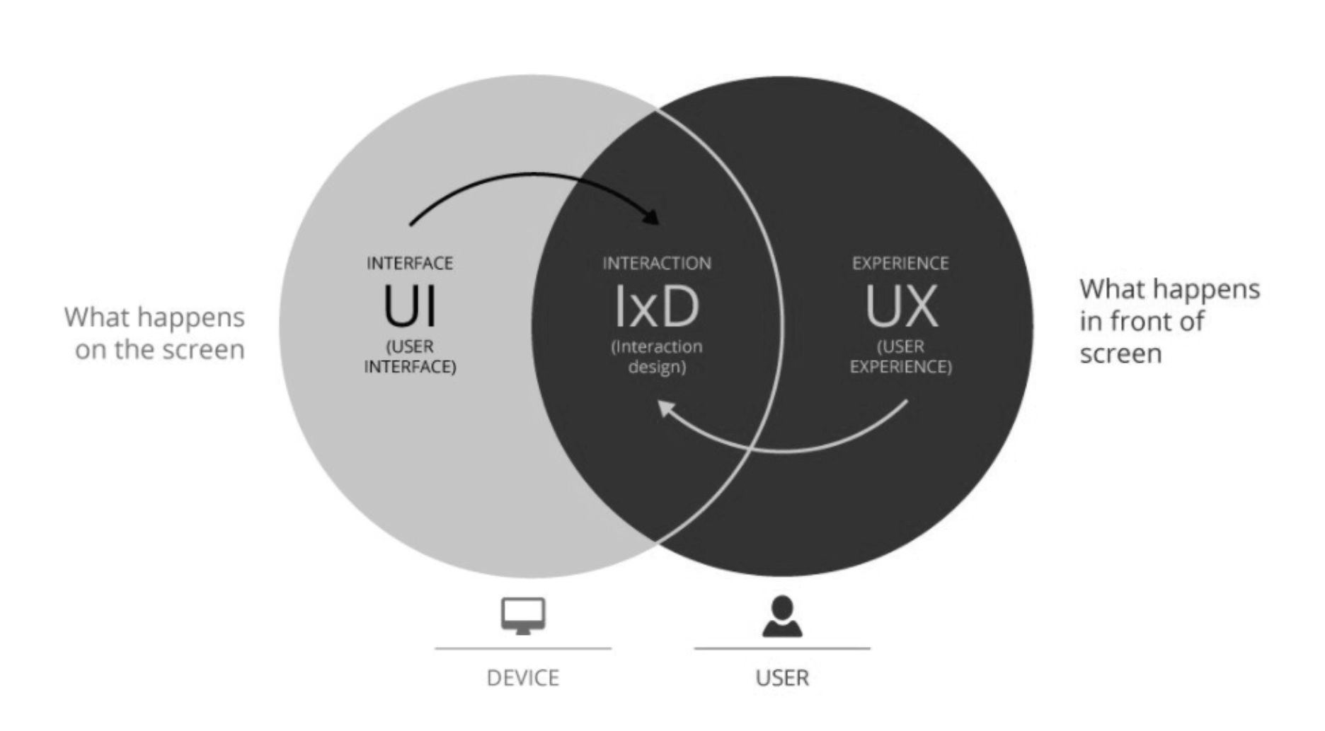

*Note.* Negative Recolour. Reprinted from Beginner’s guide: What is interaction design?. Retrieved from <https://www.qualtrics.com/uk/experience-management/customer/what-is-interaction-design/>

There is a significant distinction between UX and UI. UX comprises components that have an impact on how the user feels when interacting with the product. UI refers to how a user interacts with a product, instructs it what to do and receives a response. UX makes a product more enjoyable while UI controls how it is used. Although they are extremely different, UI and UX both depend on many of the same principles to work. (LeSuer, 2022).

The difference between UX and IxD is subtle but distinct. The difference between IxD and UI is what happens when a user interacts with the features and content of a site and how the website is created to be more user-friendly and entertaining. IxD is one of the many elements that contribute to improving UX. (LeSuer, 2022).

# 

# User Engagement

While the main goal of an interactive design is to enhance the user’s experience, it is often used with the intention to improve user engagement on a site. Attfield et al. (2011) explains what user engagement is and how to measure it.

## What is User Engagement?

Attfield et al. (2011) defines user engagement as “the emotional, cognitive and behavioural connection that exists, at any point in time and possibly over time, between a user and a resource”.

User engagement characteristics expand on the concept of engagement across three broad dimensions which are defined as Emotional, Cognitive and Behavioural. Attfield et al. (2011) lists these characteristics and their meanings. The definition of Focused Attention is paying attention to one subject exclusively. The feelings felt during interaction are referred to as Positive Affect. The visual and sensory appeal of an interface is its Aesthetics. The ability to remember an experience and the readiness to repeat or promote it defines Endurability. Novel, startling, unusual or unexpected experiences is what Novelty refers to. Richness and Control are the levels of such. User’s global trust in a particular entity is the Reputation, Trust and Expectation characteristic. Lastly, the user’s motivation, incentives and benefit form the User Context. (Attfield et al., 2011).

## How to Measure User Engagement

Metrics for evaluating the user experience can be categorised as either subjective or objective. Subjective measurements capture a user’s perception of the media at hand and is typically self-reported. A post-experience questionnaire can be used to quantify the subjective aspects of an interactive experience. The use of questionnaires and other subjective measurements has a variety of disadvantages. These include their reliance on the subjectivity of the user, post-hoc interpretation and vulnerability to the halo effect. Creating objective metrics that can accurately represent subjective experiences is a way to get around these problems. (Attfield et al., 2011).

Measurements that are objective are observable consequences, these can be metrics for the subjective sense of time, performance on subsequent tasks, physiological sensors, online behaviour and metrics for information retrieval. Asking a user to estimate how much time has passed during an activity is one way to measure the subjective sense of time. How well a user does on a separate task right after a period of engaged interaction is another possible measure of cognitive engagement. A wide variety of sensors connected to various cognitive states are capable of collecting physiological data. Eye trackers, mouse pressure, biosensors, oximeters and cameras are a few examples of sensors that can be used. The web analytics community has expressed interest in determining how users’ levels of engagement with a website may be measured. Three lines of research in Information Retrieval (IR) metrics are directly related to measuring user engagement. The first step will be to create metrics for interactive IR. This line has inspired the concept of simulated search scenarios, in which a subject has to follow a search scenario that details what, why, and in what context the user is browsing. The development of metrics that take enriched user interaction models into account is the second line of research. The final line of research connects user satisfaction to accepted IR effectiveness metrics. (Attfield et al., 2011).

# 

# JavaScript Framework

A JavaScript framework can be used to create an interactive web app. Kumar & Singh (2016) claim that “AngularJS is great for building highly active and interactive web applications”. AngularJS is a framework that can be used to develop single page interactive web applications by using HTML and JavaScript. Angular Material is a UI component library that can be used with AngularJS to style the user interface.

## AngularJS

In order to enable developers to create single page applications, Google and the community maintain an open source JavaScript framework known as AngularJS. Its goal is to make development, maintenance and testing of web applications easier by using model-view controller (MVC) functionality. AngularJS aids in the creation of HTML, CSS and JavaScript-based online applications. A distinguishing characteristic of AngularJS is automatic data synchronisation between model and view components, referred to as two-way data bindings. (Kumar & Singh, 2016).

Ramos et al. (2016) did a survey with developers to collect their perceptions about AngularJS. They found that the flexibility to design UI components using custom directives, the use of dependency injection and the simplicity of setting up two-way data bindings are three features of AngularJS that developers value. By providing a simpler interface to create reusable UI components and by utilising better techniques to detect changes in the model, JavaScript MVC framework developers can embrace these traits and enhance them. The two issues that crop up more commonly when using AngularJS templates are the appearance of silent failures and the difficulty in duplicating or debugging variables used as HTML references. Directives, particularly those involving transclusion, are the AngularJS components that are more challenging to test; the other components are generally seen as being simple to test. (Ramos et al. 2016).

## Angular Material

In order to create beautiful and consistent user interfaces more quickly, developers can use the UI component library Angular Material in AngularJS projects. It has ready to use attractive UI elements with default styling that complies with the Material Design Specification and are reusable throughout the project. (Mensah, 2019).

# 

# Conclusion

Interactive web design may be the future, or current standard, of web applications. The amount of interactivity an application needs depends heavily on the type of user the web app plans to attract. It appears to be advantageous to making a web app interactive. UI, UX and IxD play big roles in creating an enjoyable interactive experience. Understanding user engagement and how to measure it is crucial to developing an interactive application. AngularJS and Angular Material can be used to develop these aesthetic and interactive web apps.

Overall, this literature review explains the terms surrounding creating an interactive web application and examines a JavaScript framework that can be used to create one.

# 

# References

Attfield, S., Kazai, G., Lalmas, M., & Piwowarski, B. (2011, February). Towards a science of

user engagement (position paper). In WSDM workshop on user modelling for Web

applications (pp. 9-12).

Imran, T. (2021, November 2). Revolutionize your business landscape with Interactive Web

Applications. Sun Technologies. https://www.suntechnologies.com/blogs/revolutionize-your-business-landscape-with-interactive-web-applications/

Interaction Design Foundation. (2011). What is Interaction Design? The Interaction Design

Foundation; UX courses. https://www.interaction-design.org/literature/topics/interaction-design

Interaction Design Foundation. (2018). What is User Interface (UI) Design? The Interaction

Design Foundation; UX courses. https://www.interaction-design.org/literature/topics/ui-design

Interaction Design Foundation. (2019). What is User Experience (UX) Design? The Interaction

Design Foundation. https://www.interaction-design.org/literature/topics/ux-design

Kumar, A., & Singh, R. K. (2016). Comparative analysis of angularjs and reactjs. International

Journal of Latest Trends in Engineering and Technology, 7(4), 225-227.

LeSuer, S. (2022, February 1). UX vs IA vs UI vs IxD Design: Difference & What They Stand

For. Slickplan. https://slickplan.com/blog/understanding-digital-design-terms-ia-ui-and-ux#:~:text=But%20first%2C%20what%20is%20UX

Mayer, J. (2021, September 8). The Pros and Cons of Interactive Web Design.

https://designbro.com/blog/industry-thoughts/pros-cons-interactive-web-design/

Mensah, O. (2019) Creating Beautiful Apps with Angular Material. Auth0 - Blog.

https://auth0.com/blog/creating-beautiful-apps-with-angular-material/

Odugbesan, T. (n.d.). What is Interactive Web Design? . Study.com.

https://study.com/academy/lesson/what-is-interactive-web-design.html

Ramos, M., Valente, M. T., Terra, R., & Santos, G. (2016, November). AngularJS in the wild: A

survey with 460 developers. In Proceedings of the 7th International Workshop on Evaluation and Usability of Programming Languages and Tools (pp. 9-16).